|  |  |
| --- | --- |
| Canon EF 135mm f2L USM lens  Ống kính Canon EF 135mm f2L USM  Canon EF 135mm f2L USM 1 Canon EF 135mm f2L USM Canon EF 135mm f2L USM 2 Canon EF 135mm f2L USM 4 | **Featured information:**  Anti-vibration: Yes  Aperture: F/2.8-32  Closest focusing distance: 1.2m  Filter size: 77mm  Price: $ 1650  **Specifications:**  Focal distance  135mm  Largest Aperture  f/2  Smallest Aperture  f/32  Lens Mount  Canon EF  Lens Format  Full-Frame  View  18°  Minimum Focus Distance  90 cm  Magnification  0.2x  Optical Components  10 Elements in 8 Groups  Number of Mouth Blades  8  Focus Type  Autofocus  Anti-Vibration  Are not |

**Overview:**

As the ideal lens for portrait photography, the mid-telephoto Canon EF 135mm f/2L USM has become an indispensable part of Canon's L series. Long focal length and f/2 maximum aperture allow for fine control over depth of field, using selective focus. At the same time, wide aperture is more beneficial when shooting in low light conditions.

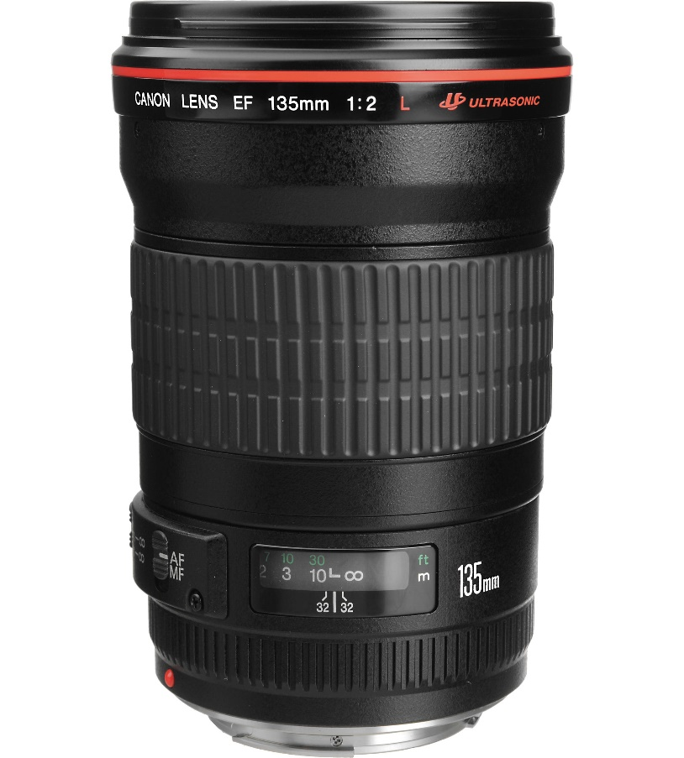

The lens weight is relatively light and compact, weighing only 750g. The large maximum aperture allows photographers to shoot with fast shutter speeds even in low light conditions without the need for flash. This makes the Canon EF 135mm f/2L USM the ideal lens for indoor sports photography.

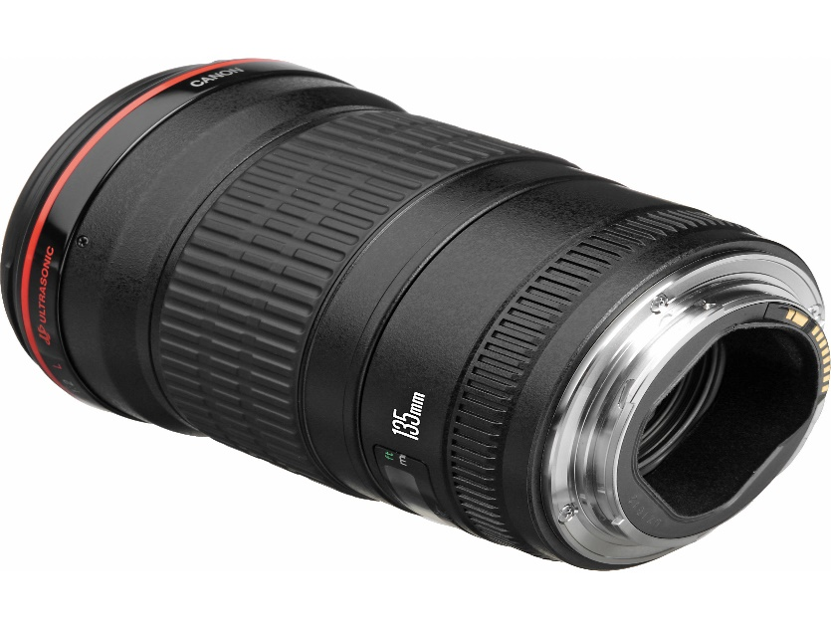

The sturdy, durable lens structure is highly appreciated in Canon's L lens series. The Canon EF 135mm f/2L USM lens is dust and moisture resistant for stable work in harsh environments. The rounded 8-blade diaphragm design contributes to smooth focus quality. It also offers an advantage when used with shallow depth of field and selective focus techniques.

